1. Hydra is a member of which domain?
a. Archaea
b. Bacteria
*c. Eukarya

2. Hydra is classified into which phylum?
a. Annelida
b. Arthropoda
c. Chordata
*d. Cnidaria
e. Platyhelminthes

3. Nematocysts are located within
*a. cnidocytes
b. gastrodermis
c. hypostome
d. mouth

4. Hydra has which type of symmetry?
a. bilateral
*b. radial

5. Hydra has
a. a complete digestive system
*b. a gastrovascular cavity

6. Which animal is not a member of the same phylum as hydroids?
a. box jellies
b. corals
c. jellies
d. Portuguese man-of-wars
*e. sea cucumbers

7. What type of nervous system is found in Hydra?
a. anterior pair of ganglia with ventral nerve cords
b. cerebral ganglia, ventral nerve cords, and segmental ganglia
c. complex folded brain, spinal cord and nerves
*d. nerve net

8. Is Hydra diploblastic or triploblastic?
*a. diploblastic
b. triploblastic

9. Which type of body plan is present in Hydra?
a. medusa
*b. polyp
10. On the Hydra diagram below, the structure labeled “a” is the
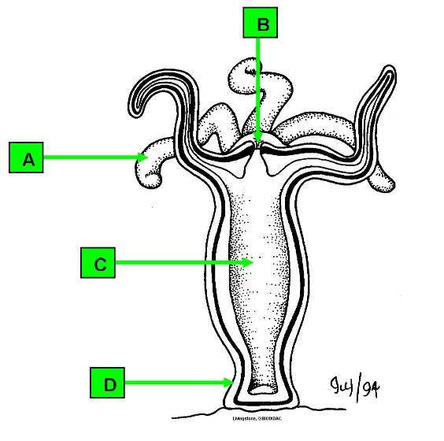

a. basal disc
b. gastrovascular cavity
c. mouth
*d. tentacle

11. On the Hydra diagram below, the structure labeled “b” is the

a. basal disc
b. gastrovascular cavity
*c. mouth
d. tentacle

12. On the Hydra diagram below, the structure labeled “c” is the

a. basal disc
*b. gastrovascular cavity
c. mouth
d. tentacle

13. On the Hydra diagram below, the structure labeled “d” is the

*a. basal disc
b. gastrovascular cavity
c. mouth
d. tentacle

14. On the Hydra diagram below, the circled structure is a
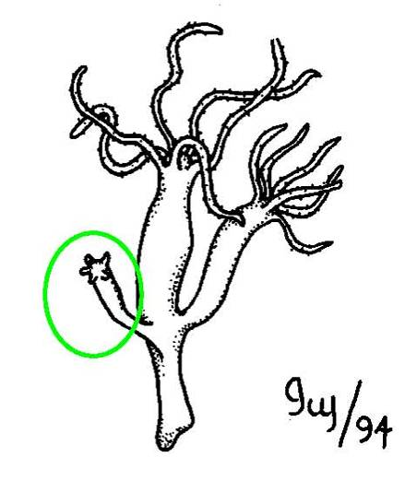
a. basal disc
*b. bud
c. medusa
d. tentacle

15. The structure labeled "a" on the diagram of a Hydra wall section is the
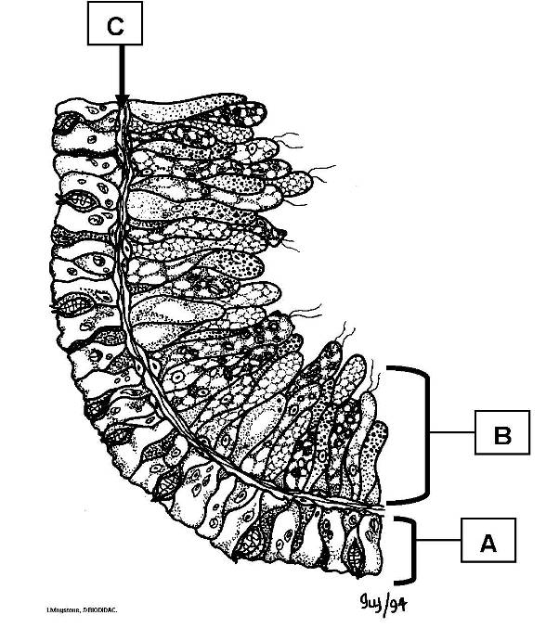

*a. epidermis
b. gastrodermis
c. mesoglea

16. The structure labeled "b" on the diagram of a Hydra wall section is the

a. epidermis
*b. gastrodermis
c. mesoglea

17. The structure labeled "c" on the diagram of a Hydra wall section is the

a. epidermis
b. gastrodermis
*c. mesoglea

